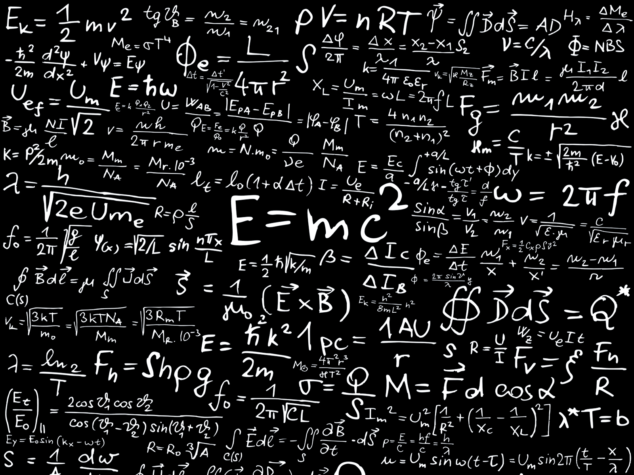

Tarea 1

Matemática Discreta

Andrés Montenegro

UTC

Ejercicios 5 y 6

* U = {1,2,3,4,5,6,7,8,9}
* A = {1,2,4,6,8}
* B = {2,4,5,9}
* C = {x|x es entero positivo y } = {1,2,3,4}
* D = {7,8}

5. Calcule

1. A u B = **{1,2,4,5,6,7,8,9}**
2. A u C = **{1,2,3,4,6,8}**
3. A u D = **{1,2,4,6,7,8}**
4. B u C = **{1,2,3,4,5,9}**
5. A n C = **{1,2,4}**
6. A n D = **{1,2,4,6,7,8}**
7. B n C = **{2,4}**
8. C n D = **{}**
9. A – B = **{1,6,8}**
10. B – A = **{5,9}**
11. C – D = **{1,2,3,4}**
12. C’ = **{5,6,7,8,9}**
13. A’ = **{3,4,7,9}**
14. A + B = **{1,2,2,4,4,5,6,8,9}**
15. C + D = **{1,2,3,4,7,8}**
16. B + C = **{1,2,2,3,4,4,5,9}**

6. Calcule

1. A u B u C = **{1,2,3,4,5,6,8,9}**
2. A n B n C = **{2,4}**
3. A n (B u C) = **{1,2,4}**
4. (A u B) n D = **{1,2,4}**
5. (A u B)’ = **{3}**
6. (A n B)’ = **{1,3,5,6,7,8,9}**
7. B u C u D = **{1,2,3,4,5,7,8,9}**
8. B n C n D = **{}**
9. A u A = **{1,2,4,6,8}**
10. A n A’ = **{}**
11. A u A’ = **{1,2,3,4,5,6,7,8,9}**
12. A n (C’ u D) = **{6,8}**

Ejercicios 7 y 8

* U = {a,b,c,d,e,f,g,h}
* A = {a,c,f,g}
* B = {a,e}
* C = {b,h}

7. Calcule

1. A’ = **{b,d,e,h}**
2. B’ = **{b,c,d,f,g,h}**
3. (A u B)’ = **{b,d,h}**
4. (A n B)’ = **{b,c,d,e,f,g,h}**
5. U’ = **{}**
6. A – B = **{c,f,g}**

8. Calcule

1. A’ n B’ = **{b,d,h}**
2. B’ u C’ = **{b,c,d,e,f,g,h}**
3. (A u A)’ = **{b,d,e,h}**
4. C’ n C’ = **{a,c,d,e,f,g}**
5. A + B = **{a,a,c,e,f,g}**
6. B + C = **{a,b,e,h}**